The webpage Is created using basic HTML, CSS and PHP. Phpmyadmin was used to emulate an underlying SQL database. The webpage consists of a login, signup, profile and update settings page.

Database users having the columns: Username(unique), First name, Last Name, Telephone, Status(Student, Teacher or Admin) Password (Hashed password stored), Email.

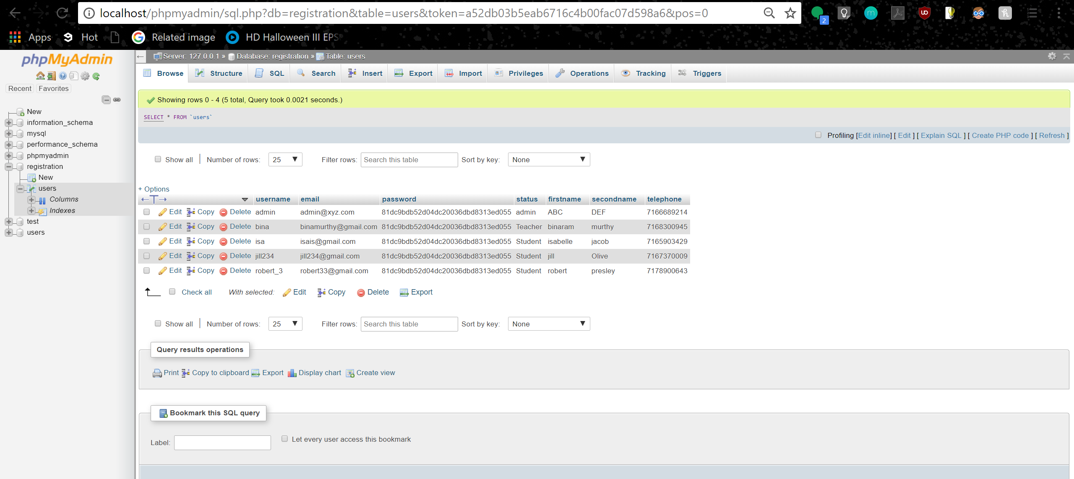

Login Page

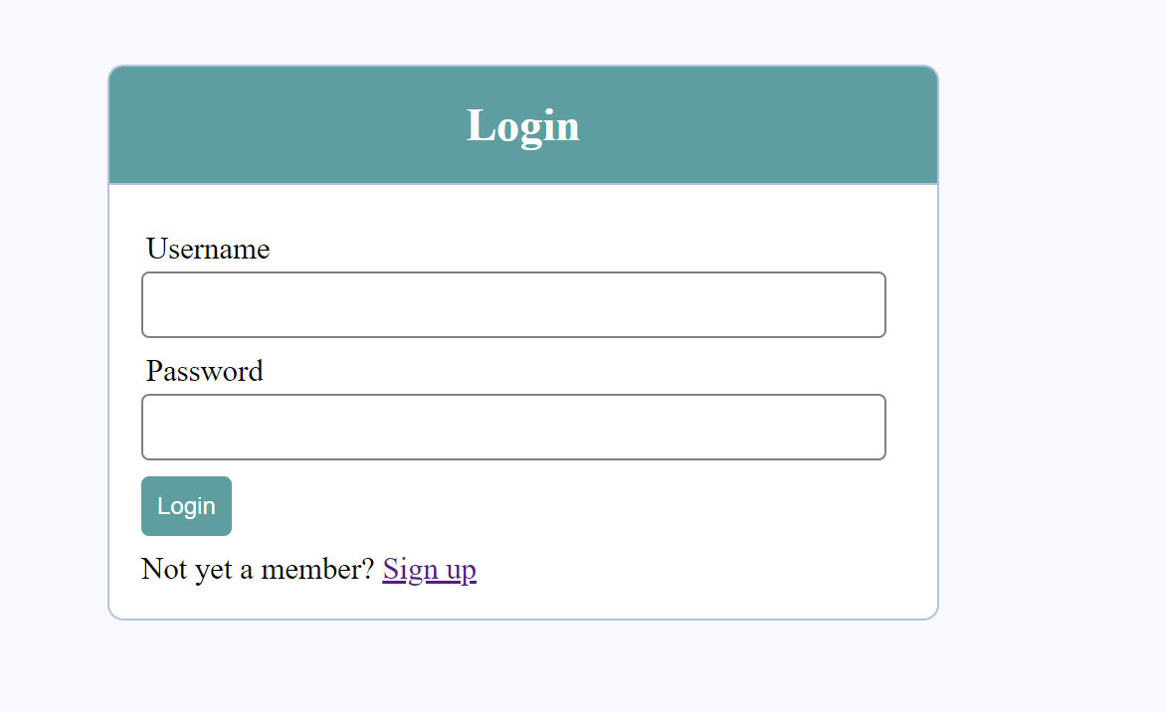

On entering a wrong username or password

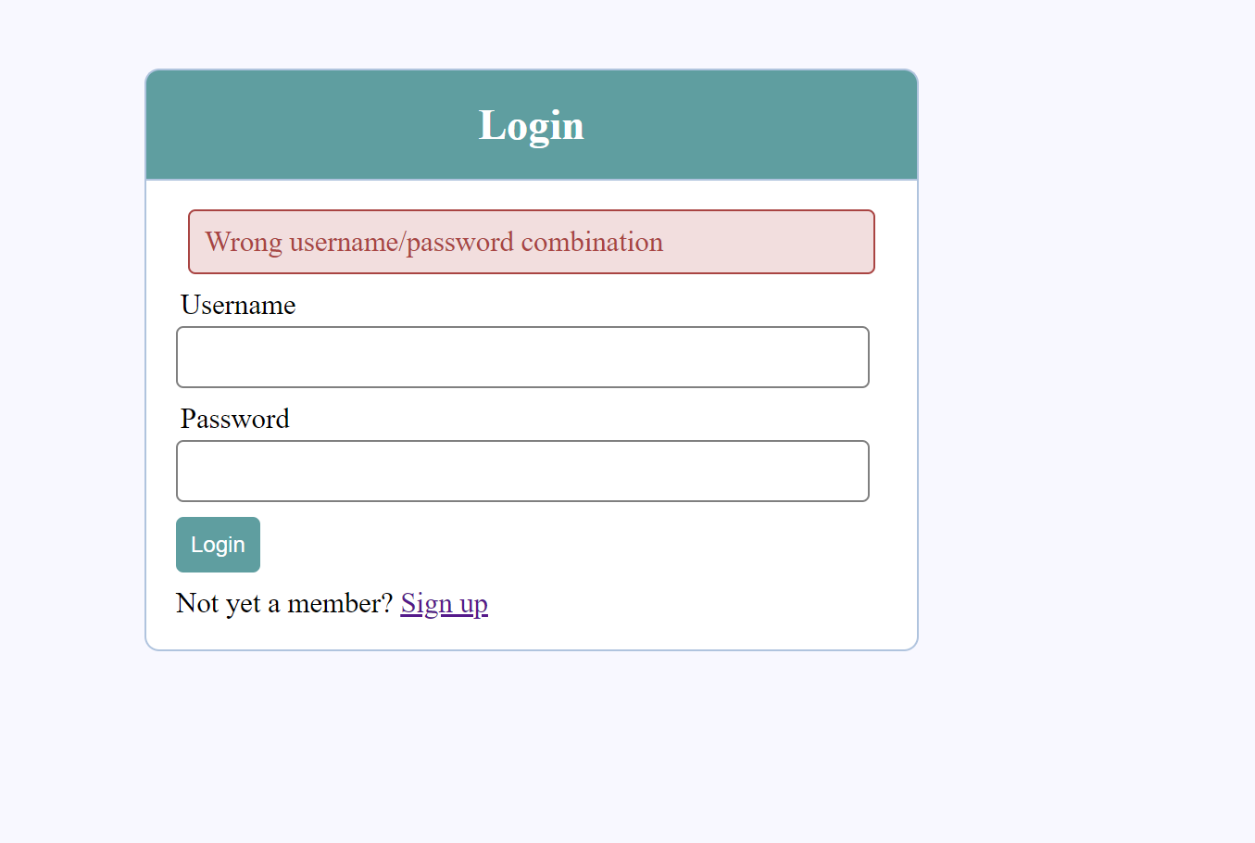

On entering the right credentials

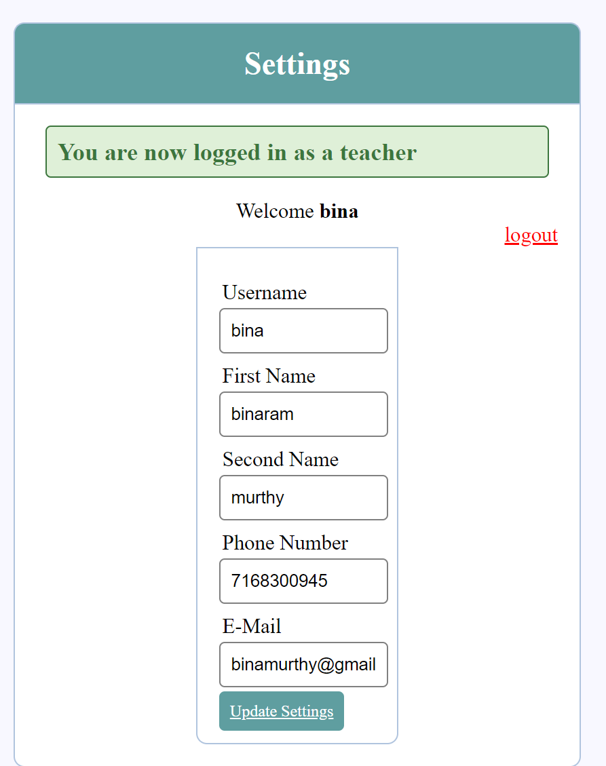

On clicking logout, we are again shown the Login page



Sign up or register page

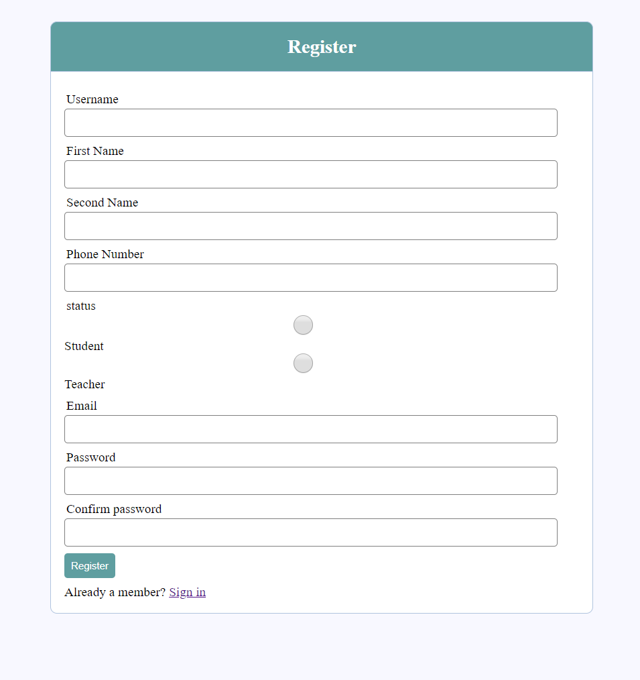

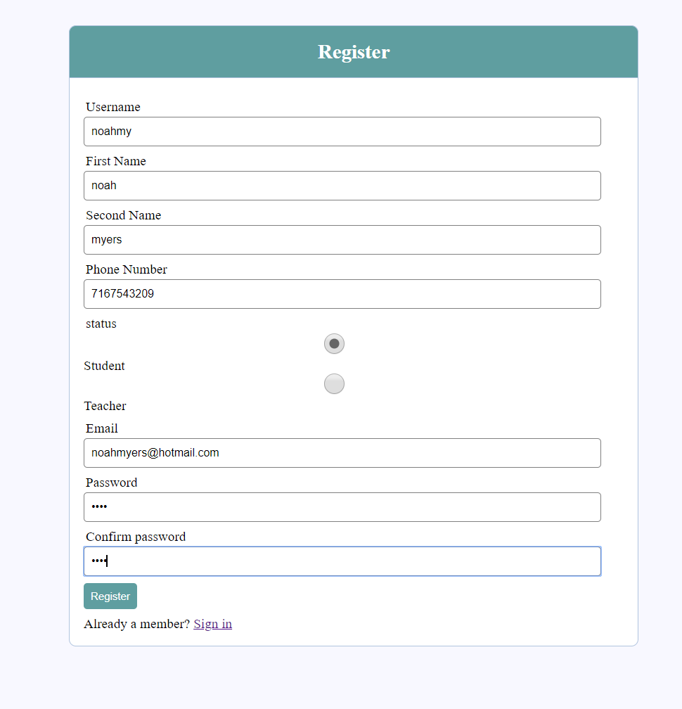

On clicking register button

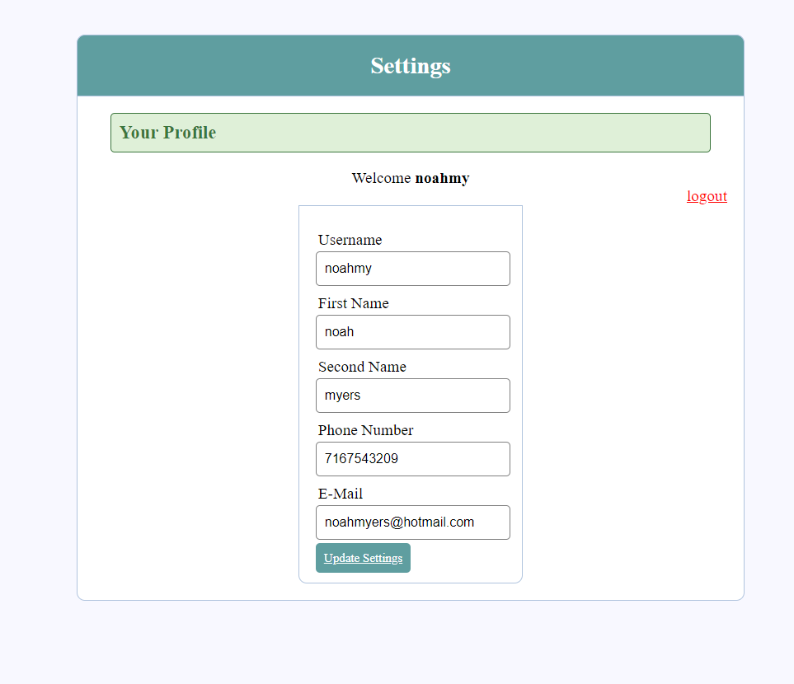

User added to database

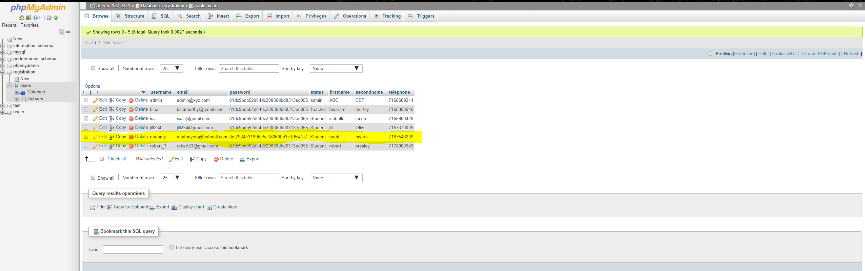

Update Settings page

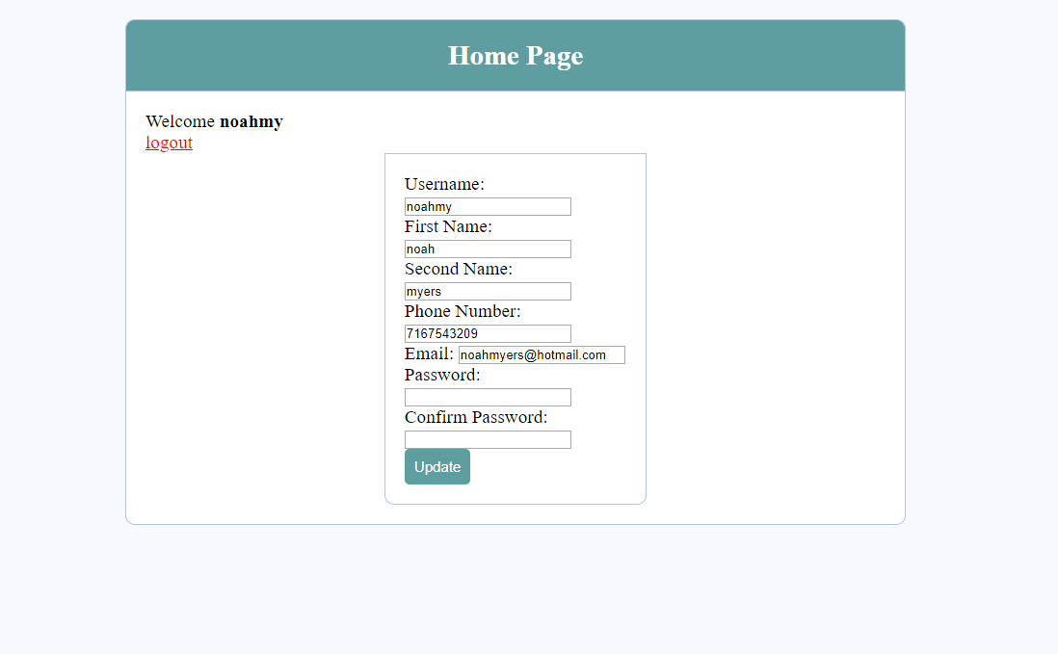

On clicking update button

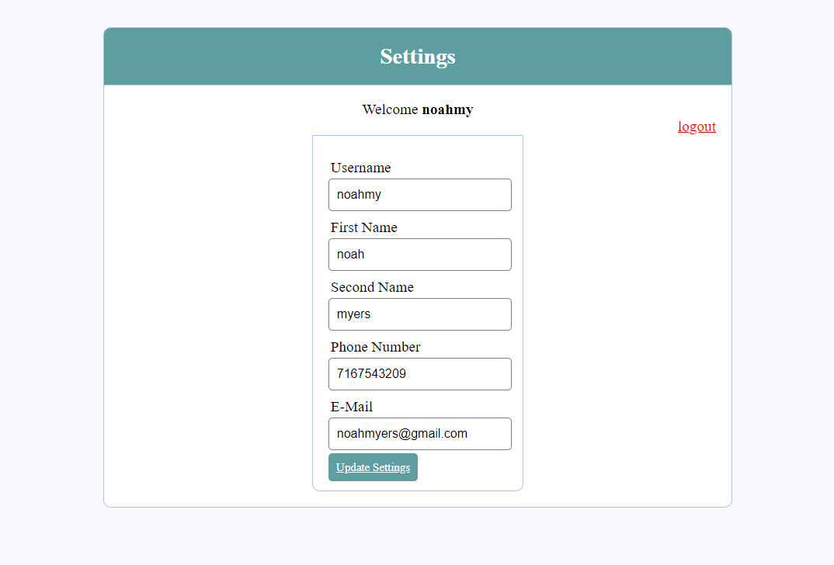

Database updated

